2011中国汽车工程学会年会住房预订表
2011 SAE China Congress Reservation Form

需预订住宿的参会代表请于10月1日前完成预订，住宿费自理。酒店房间有限，预订从速。预订方式如下：The participants, who need to reserve accommodation, please complete reservation before October 1, and you should pay the hotel expense by yourself. The hotel room has a fixed number. Please reserving as soon as possible, if your want to scheduled. And the reserving form is below.

1、如预订亚运村宾馆请登录网站www.huiyuangongyu.com.cn 在线预订，点击“会议预定”，点击“2011中国汽车工程年会”，进入登陆页面后，输入登陆密码“0”进行预订。If you want to reserve the Yayuncun hotel, please log on reserving web site www,huiyuangongyu.com.cn. Click on “reserve for the convention” and then click on the "2011 SAE China Congress" ,when you see the landing pages , input your password “0” .
2、如预订北京亚奥国际酒店，请直接填写住宿预定表（如下表），按照要求进行预订。If you want to reserve Best Western OL Stadium Hotel Beijing, please fill in the form on request.
3、酒店预订服务咨询请联系周小姐010-87510823-806。Please contact Miss Zhou for Hotel reservation,TEL,+86-10-87510823-806

请将此表于10月01日前通过传真或邮件发给周小姐
Please send the form to Mr. Derek before October 1st, 2011 by Email or Fax
Email: 2011saecc@sina.com;Tel:010-87510823-806;Fax:010-87510823-803; Cell: 15120060501
姓  Last Name |  | 名  First Name
性别  Gender |  | 电话  Tel
邮箱  Email |  | 传真  Fax
入住日期  Arrival Date | Apr. | 离店日期  Departure Date Date | Apr.
亚运村宾馆  Yayuncun Hotel  (★★★) | □ 2床标准间，RMB300元/间天  Standard Room RMB300Yuan/per night, □2 Single Beds □1 Kingsize Bed
北京亚奥国际酒店  Best Western OL Stadium Hotel Beijing  (★★★★) | □ 2床商务标准间，RMB470元/间天  Business Standard Room: RMB470 Yuan/per night,  □2 Single Beds □1 Kingsize Bed
北京亚奥国际酒店  Best Western OL Stadium Hotel Beijing  (★★★★) | □ 大床商务套间，RMB770元/间天  Business Suite RMB750Yuan/per night,□1 Kingsize Bed
特别要求
Special Request

- 如传真预订，请在选择框□上划√。如邮件确认，请将选项文字标红。如有问题，请联系周小姐。Please tick the square (□) if you choose fax for reservation. Please mark the line red if you choose email for reservation. Any question, please contact Miss Zhou.
- 以上酒店价格均含早餐。不接受拼房服务。Room Rate Including Buffet Breakfast. No room-sharing service provided.
- 距国家会议中心约5分钟车程，酒店将安排班车接送客人至会场。It’s five-minute drive to the Congress venue and a shuttle bus will be arranged sending guests to CNCC (Congress Venue).
- 更多交通信息也可登录酒店网址www.huiyuangongyu.com.cn查看。Please log on hotel website www.huiyuangongyu.com.cn and congress website for traffic information.
- 亚运村宾馆地址：中国北京市朝阳区北辰东路8号。电话：010-64991199。
Yayuncun Hotel: No.8 North Star East Road, Chaoyang District, Beijing, China.TEL: 8610-64991199
北京亚奥国际酒店地址：北京市朝阳区北沙滩大屯路甲1号，电话：010-64874433。
Best Western OL Stadium Hotel Beijing: No.1BeiShaTan DaTun Road, Chaoyang District, Beijing, China. TEL: 8610-64874433
- 会场交通图如下：The map of venue is below.

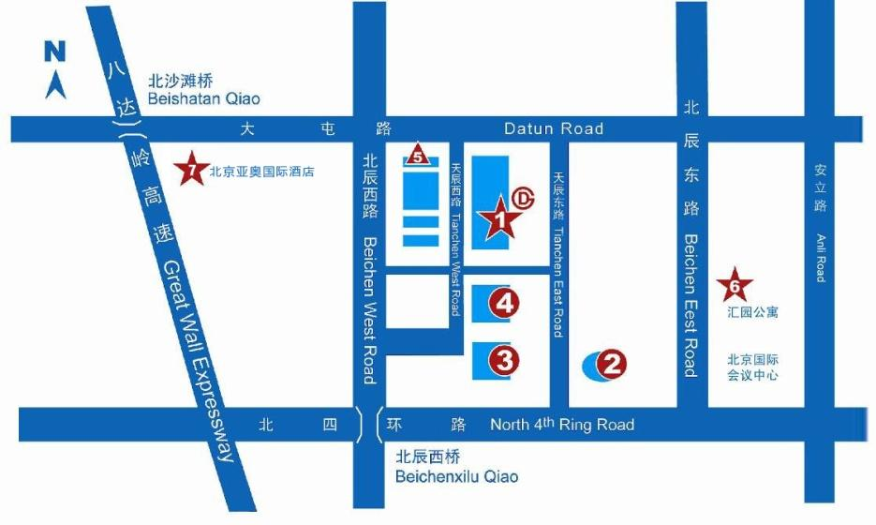
1、国家会议中心China National Convention Center
6、亚运村宾馆Huiyuan Prime Hotel
7、北京亚奥国际酒店Best Western OL Stadium Hotel Beijing
2、鸟巢Beijing National Stadium
3、水立方Water Cube
4、国家体育馆The National Stadium

